**Software Requirements Specification**

**“DEAN RSPC”**

**Prepared by: Project Under:**

Ayushmaan Verma Atul Gupta

**1. Introduction**

**1.1 Purpose**

The software requirement specification document is specifically designed to delineate the boundaries of the dean RSPC design and functionality. Parties interested in this documentation would include, but not be limited to the system owners, the system users, the project manager and the design team.

The RSPC Module is a part of the Fusion project that is responsible for maintaining the record of projects of professors, their achievements, conferences, book publications, etc. It provides a platform for professors and staff members to add projects and their details, which are not visible to other users of the system. In addition, the module also maintains the profiles of professors and staff members, which includes their projects, achievements, etc.

This is software designed to manage different activities related to the dean RSPC department of PDPM IIITDM Jabalpur. The software is designed to provide automated features to Faculty, Dean, and Staff. The different activities that come under the dean RSPC department such as project funds, eis etc.

The software will also have a consultancy section where the user can add the details of the consultancy project i.e., Consultant name, Client name, Project start and end date and also the financial outlay.

**1.2 Scope of the Document**

The scope of the RSPC Module is to provide a platform for professors and staff members to manage their projects, achievements, conferences, book publications, etc. It also maintains their profiles and allows them to add projects and their details. The module ensures that the information added by professors and staff members is not visible to other users of the system.

In addition to the specific design components of this software, this document will make clear the design team’s goals of creating value-added software which not only correctly captures faculties data, but then efficiently stores it, sorts it, retrieves it, and delivers this critical care information where it is needed by Dean and Staff.

This software is deliberately focused on Faculty data and dean responsibilities. It is important to point out that this system will have functionality regarding appointment management, and billing.

**1.3 Intended Audience and Reading Suggestions**

The audience for the document reading are users of the system such as the administration body, Present Dean RSPC and faculty. Developers of the software will use it as a basis for making design and coding.

**2. Overall Description**

**2.1 Product Perspective**

At present there is no such integrated automated system for dean RSPC in our college. All different activities are done manually and carried out independently. Current software will interact to provide necessary functionality in some activities.

Faculty data and projects fund details are the keystone to the dean RSPC department; however, these records are not utilized to their fullest potential. Often records are inaccurate, misplaced, and /or duplicated unnecessarily. In a world which recognizes the improvement of data digitization and networking as a constructive force which often increases efficiency while lowering costs; it is our view that faculty data and projects records networking could only benefit the quality of work and data offered.

It’s going to take care of the financial things/fundings, whether the product is financially feasible or not. What will be its limitations, advantages/disadvantages etc.

Integrated with EIS, i.e. Employee Information System. In this section, the employee or the user can also view/edit the status(If the project is submitted or it is still going on or it is completed or they are awarded) of the project, that is he/she can interact with the RSPC section.

Research projects/Consultancy Projects are also going to come under this module, that is which project is under which employee/faculty. Patent information is also going to be available on EIS, of the projects.

**2.2 Product Functions**

The major functions that product will perform are:

**Online Apply for Project Registration**

The Faculty can apply for online registration for project and that application go to the HOD of the department. HOD check the application and then forwarded to the dean RSPC staff then staff and admin view the application and then forwarded the application to present Dean RSPC and depend upon the fund amount dean RSPC approve or forward the application to the director.

**Request for Extension of project**

The Faculty can request for the extension of project and that application go to the HOD of the department. HOD check the application and then forwarded to the dean RSPC staff then staff view the application and then forwarded the application to present Dean RSPC. Dean RSPC can approve or reject the application with a remark.

**Reallocation of the fund Among Different Heads**

The Faculty can apply for reallocation of the fund from one head to another head that application go to the HOD of the department. HOD check the application and then forward to the Deputy register. He checks and forward the application to dean RSPC staff then staff view the application and then forwarded the application to present Dean RSPC.

**Request for closure of project**

If the Faculty complete the project and want to close the project the apply online and that application go to the HOD of the department. HOD check the application and then forwarded to the dean RSPC staff then staff view the application and then forwarded the application to present Dean RSPC.

**Form for issuing of final UC, SE & Closure of Project**

For issuing of final utilization certificate & statement of expenditure he applies online and that application go to the HOD of the department. HOD check the application and then forwarded to the dean RSPC staff then staff view the application and then forwarded the application to present Dean RSPC.

**Registration of Consultancy project**

A consulting project basically addresses the problem at hand and tries to overcome it by implementing different ideas and strategies. Project faces hundreds of problems relating to their operations, development, users, finances, and other significant factors.

**User Needs**

The consultant and the client are going to use the project. Other users can also see/check the details/consultancy reports status about the project like dean, staff and faculty.

Through EIS user can see the RSPC profile and can also navigate to that section. Consultancy projects and their details can also be deleted through it.

**2.3 User Classes and Characteristics**

There are seven types of users that interact with the system.

They are:

* Faculty
* Head of Department
* Dean RSPC
* Admin
* Deputy Registrar

Each of these five types of users has different use of the system so each of them has their own requirements.

1.Faculty: A person who has been applying for different type of permission.

* **Online Apply for Project Registration**
* **Request for Extension of project**
* **Reallocation of the fund Among Different Heads**
* **Request for closure of project**

2.Admin: A person who checks and forwards the different types of applications to the dean RSPC staff.

3. Head of Department: A person who checks and forwards the different types of applications to the dean RSPC staff.

4. Deputy Registrar: A person who checks and forwards the different types of applications to the dean RSPC staff.

5.Dean RSPC: A person who approves different types of applications or forward to the director depends upon the rights.

**2.4 Operating Environment**

The software will be web-oriented and will run on all web browsers.

**2.5 Design and Implementation Constraints**

The document contains many use cases so when forming a design for the software we need to consider appropriate design models that will help the developers, coders and testers to implement their tasks. Legacy systems in place must be considered and modified to interface with the new system design.

Both the dean and registrar faculty database will need large storage capabilities and a process to archive outdated data.

The Internet connection is also a constraint for the application. Since the application fetches data from the database over the Internet, it is crucial that there is an Internet connection for the application to function.

**2.6 User Documentation**

A use case diagram is provided with the functional requirements to represent the entire information in a single picture. Further user documentation will be provided later.

**3. External System Requirements**

**3.1 User Interferences**

The software provides a good graphical interface for the user. Any administrator can operate on the system performing the required tasks.

The user interface of this project is dependent on the UI Team. The theme used in the project will be provided by the UI Team.

**3.2 Hardware Interfaces**

There is no need for specific hardware interfaces to run the software on the computer system.

**3.3 Software Interfaces**

As documented earlier that the software project is closely related with project such as dashboard, faculty information system and database design project. The software interfaces used to combine all these projects will be discussed later.

**3.4 Communications Interfaces**

The software will support web browsers such as Google Chrome, Mozilla Firefox and Safari. The communication standard used can be FTP or HTTP.

**4.Functional Requirements**

**Use Case Model**

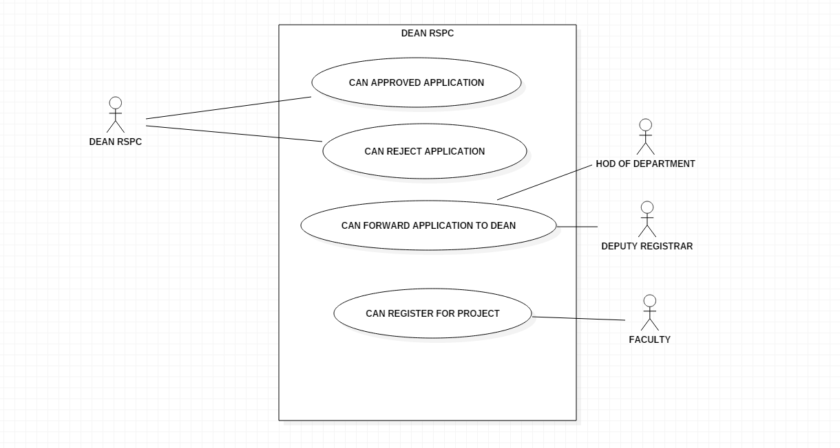

**Use Cases**

**1.Approved**

| Use Case Name | Approved |
| --- | --- |
| Version | 1 |
| Description | Gives to actor to approved the application |
| Actors | Dean RSPC/ Director |
| Pre-Condition | User is logged in and clicks the View Applications Button |
| Main Flow | 1.Views the unapproved applications. |
| Post-Condition | Successfully approved the application |
| Issues | Any Network Error |

**2. Forward**

| Use Case Name | Forward |
| --- | --- |
| Version | 1 |
| Description | Allows user to forward the application |
| Actors | Faculty/HOD/Dean RSPC/Dean RSPC staff/deputy Registrar/admin |
| Pre-Condition | User is logged in and clicks request forward button. |
| Main Flow | 1.Get the Application and check it.  2. Forward the application. |
| Post-Condition | The form is successfully forwarded |
| Issues | Any Network Error |

**3. Reject**

| Use Case Name | Reject |
| --- | --- |
| Version | 1 |
| Description | Reject the application with a remark |
| Actors | Dean RSPC/Director |
| Pre-Condition | User is logged in and clicks the reject Button. |
| Main Flow | 1.User check the Application  2.If find somethings wrong then reject application |
| Post-Condition | The application is successfully rejected |

**4. Apply**

| Use Case Name | Apply |
| --- | --- |
| Version | 1 |
| Description | User apply for different type of applications/Project. |
| Actors | Faculty |
| Pre-Condition | User is logged in and clicks on the proper application. |
| Main Flow | 1. When the user click on application a form open front of him/her  2. fill the form and click on the apply. |
| Post-Condition | Successfully applied. |

**Some More Functional requirements:**

**Functional Requirements**

**The following are the functional requirements of the RSPC Module:**

**3.1. Login and Authentication**

**The module must have a login and authentication system to ensure that only professors and staff members can access their profiles and add information related to their projects, achievements, etc.**

**3.2. Profile Management**

**Professors and staff members must be able to create and manage their profiles.**

**Profiles should include information related to their projects, achievements, conferences, book publications, etc.**

**The module must ensure that the information added by professors and staff members is not visible to other users of the system.**

**3.3. Project Management**

**Professors and staff members must be able to add projects and their details.**

**The module must provide a platform to add project details, such as the title, start and end date, description, collaborators, funding agency, etc.**

**Professors and staff members must be able to view, edit, and delete their projects.**

**3.4. Achievement Management**

**Professors and staff members must be able to add their achievements, such as awards, grants, patents, publications, etc.**

**The module must provide a platform to add achievement details, such as the title, date, description, collaborators, funding agency, etc.**

**Professors and staff members must be able to view, edit, and delete their achievements.**

**3.5. Conference Management**

**Professors and staff members must be able to add details related to conferences they have attended or organized, such as the name of the conference, date, venue, etc.**

**The module must provide a platform to add conference details.**

**Professors and staff members must be able to view, edit, and delete their conference details.**

**3.6. Book Publication Management**

**Professors and staff members must be able to add details related to books they have authored or edited, such as the title, date, publisher, etc.**

**The module must provide a platform to add book publication details.**

**Professors and staff members must be able to view, edit, and delete their book publication details.**

**3.7. Search and Filter**

**The module must allow professors and staff members to search and filter their projects, achievements, conferences, book publications, etc.**

**Non-Functional Requirements**

**The following are the non-functional requirements of the RSPC Module:**

**4.1. Security**

**The module must ensure that the information added by professors and staff members is not visible to other users of the system.**

**The login and authentication system must be secure.**

**4.2. Usability**

**The module must be easy to use and navigate.**

**The user interface must be intuitive and user-friendly.**

**4.3. Performance**

**The module must be fast and responsive.**

**The search and filter functionality must be optimized for performance.**

**5.Non-functional Requirements**

**5.1 Performance Requirements**

∙ The database should be designed in such a manner that it can handle heavy loads on the server.

∙ Response in database should be visible as soon entry is made.

∙ Time spent during transactions of money should be less.

**5.2 Safety Requirements**

The different safety requirements are as follows:

∙ More than three attempts at login and failure will produce a red flag to system administrator.

∙ Logs and check points in the database should be used to handle transaction failures.

∙ Backup and recovery features should be present in the database.

∙ There should be a mechanism to handle loss of data over the network.

∙ When transferring password over the network, the method used must be secure.

∙ When transferring password, it should be in encrypted form.

**5.3 Prescription report**

∙ Prescription report associated with every appointment that patient has will be sent to patient.

∙ This will help in keeping a track of medical history of patient and will help doctors in future treatment.

**5.4 Software Quality Attributes**

The different software quality attributes are as follows:

∙ Availability: The software should be made available 24 X 7.

∙ Correctness: When carry out calculations, the software should be precise till 3 places after decimal.

∙ Maintainability: The software should be designed in such a manner so that when incorporating new changes, it should be an easy task.

∙ Reliability: The software should be reliable as it contains personal information of students, faculty and institute related information.

∙ Usability: The user interfaces should be design in such a manner so that they are interactive and user can easily interpret different functions of the software without studying any user manual.

**6. Conclusion**

This SRS document is used to give details regarding dean RSPC service System.

Also giving details regarding consultancy projects. Made some required changes in the description and the product functions.

In this all the functional and non-functional requirements are specified in order to get a clear-cut idea to develop a project.

**7. References**

∙ Dean RSPC Staff

∙ College Faculty